Fixguru Retesting

PDF issue
Should display qtn external id
Should add the item level discount column
Return the wrong item code , should return the external SKU code from Autocount
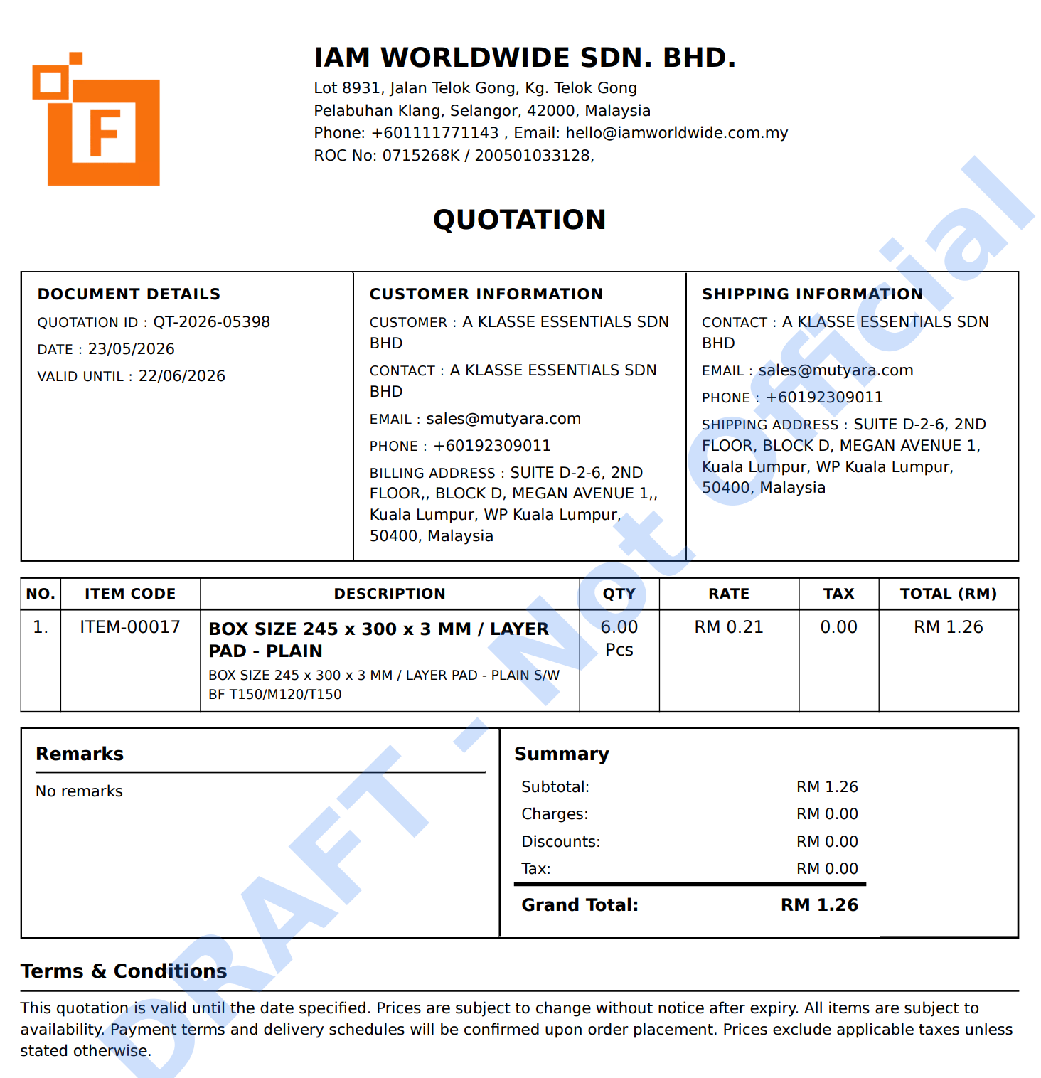

Shipping Method - Fixed
Shipping method not found
Can input shipping id so far
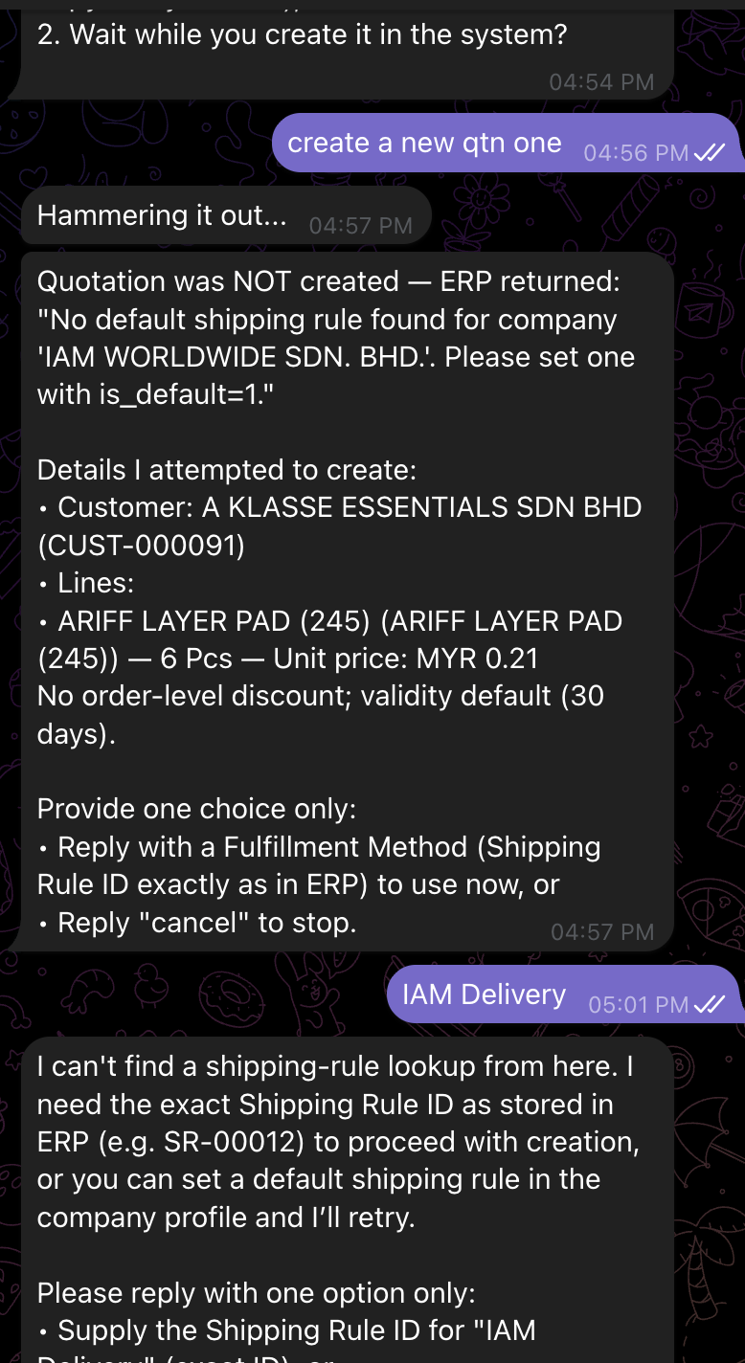

The discount value doesn't reflect after adding the discount to the line items
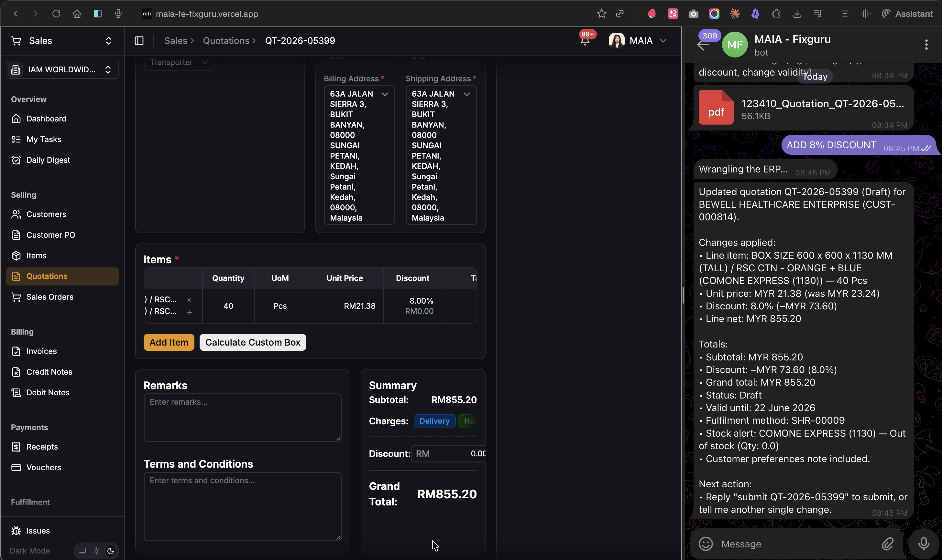

FOC Items
Free items are not allowed to submit the order
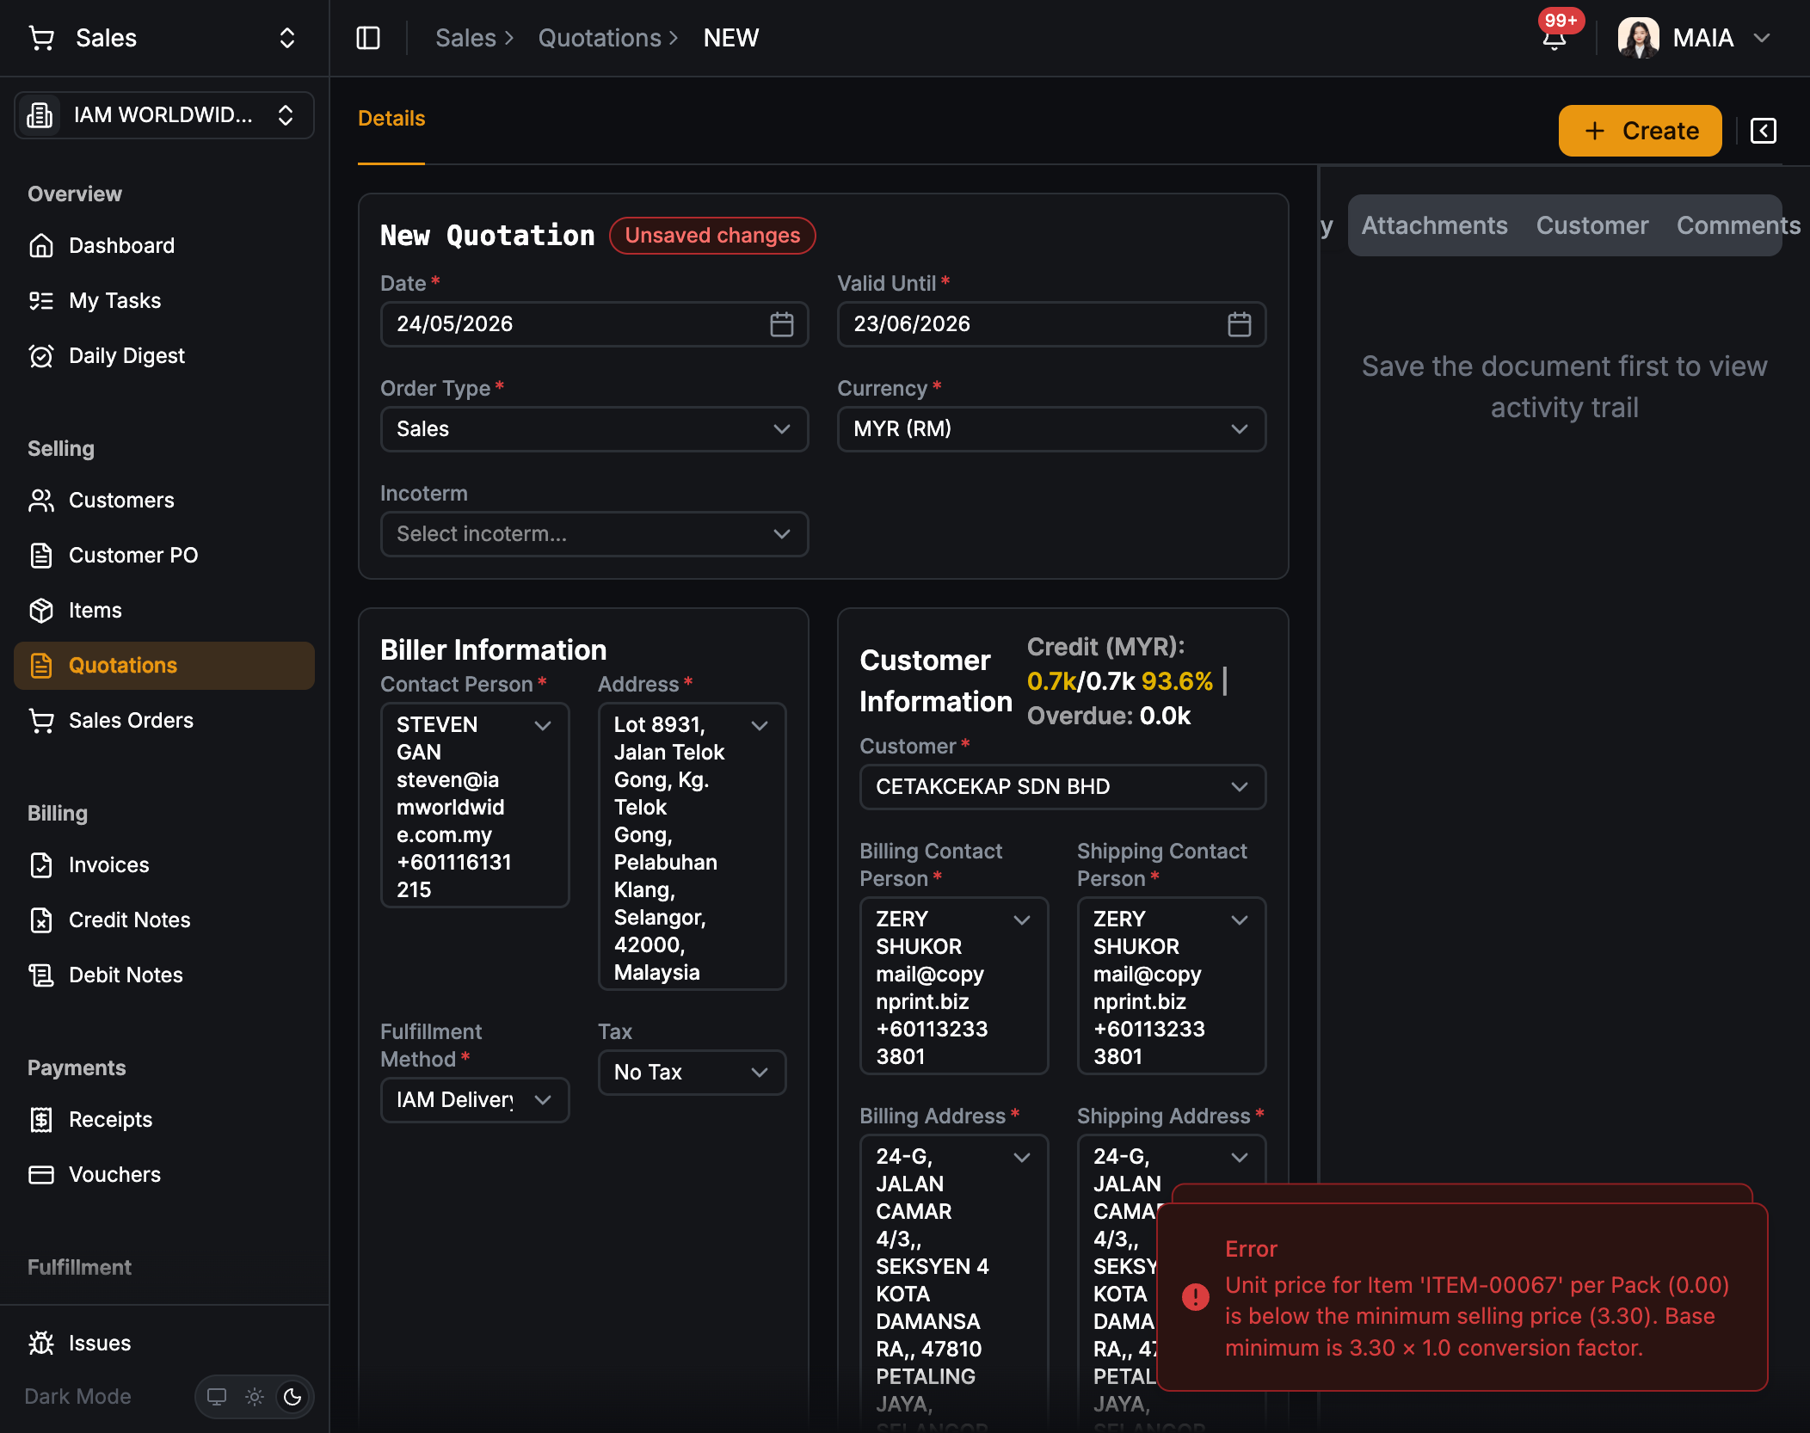

Item Historical Pricing (Chatbot)

Test Scenarios Covered

1.1 Discount Price Display
Expected Chatbot Output:
Plain Text
Unit Price: RM 3.00 Discount: RM 0.05 (4%)
Markup Price: RM 4.00 Markup: RM 0.05 (5%)
- Chatbot correctly surfaces discount % AND markup % from historical pricing record
- Discount amount and percentage displayed accurately

1.3 Volume Test — 10 Transactions
- need to test across 10 historical transactions
- Gap identified: Image/graph rendering enhancement needed — chatbot should render historical pricing trend visually, not just as text

Submitted QTN Amendment @Amirul Iman bin Amran
Scope: Chatbot + FE + BE
Fields: Item (add/remove/change), Unit Price
Issue — No QTN Amendment API
- QTN amendment API does not exist (SO has it, QTN does not)
- Impact: cannot amend submitted QTN via any channel
- Action: raise as upcoming feature; not a UAT blocker

2. Customer Pricing Enforcement (Chatbot)

Query Scenarios Required
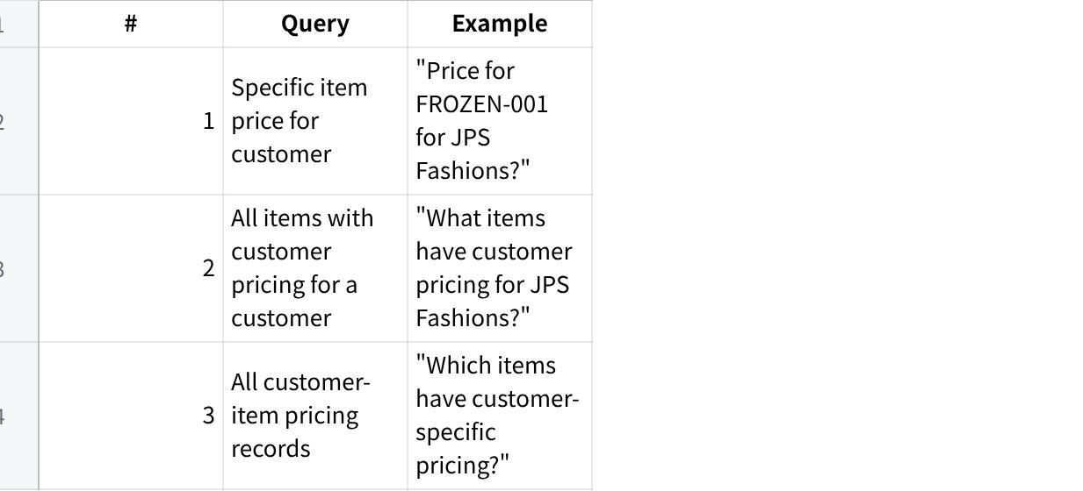
点击图片可查看完整电子表格

Test Data

点击图片可查看完整电子表格

Expected Chatbot Output
Plain Text
Customer: JPS FASHIONS (MALAYSIA) SDN BHD
Item: FROZEN-001 (Nos)
Price: RM 8.75 (30% discount from std price)
Want me to create a QTN or SO?

Issues
Issue 1 — Inconsistent retrieval, retry required
- First fetch for ORGANIC-YOGURT-500G returned 0 results; correct price (RM 2.37) only returned after retry
- Root cause: BE endpoint only supports specific item + customer lookup; broader call returns validation error
- Action: fix first-call reliability for specific item pricing
Issue 2 — Last transaction record appears in customer pricing response
- FROZEN-001 response included "Last recorded transaction: QT-2026-01397" — not expected
- Root cause: chatbot mixing customer pricing lookup with historical pricing lookup
- Action: decouple; suppress last transaction from customer pricing output
Issue 3 — Open-ended query instead of proactive lookup
- "Can u check JPS Fashions customer pricing" → chatbot asked clarifying questions instead of returning what exists
- Root cause: no BE endpoint for listing all customer-priced items per customer; chatbot falls back to asking user
- Action: build BE endpoint (links to Issue 4); update chatbot to query proactively
Issue 4 — Full catalogue scan not supported (BE gap)
- Scenarios 2 & 3 consistently return validation error and 0 results
- Root cause: BE endpoints for Scenarios 2 & 3 not built
- Action: raise as feature request — build BE endpoints for (a) all items with customer pricing per customer, (b) all customer-item pricing records
Issue 5 — Cannot create customer pricing via chatbot
- Chatbot: "I can't set a permanent customer-specific price directly — the system tool to set customer price isn't available to me."
- Action: expose customer pricing creation tool to chatbot or define FE/BE enforcement flow

4. FE Issues — Customer Price Enforcement @Amirul Iman bin Amran
FE Issue — Lock violation shown on submit, not at field level
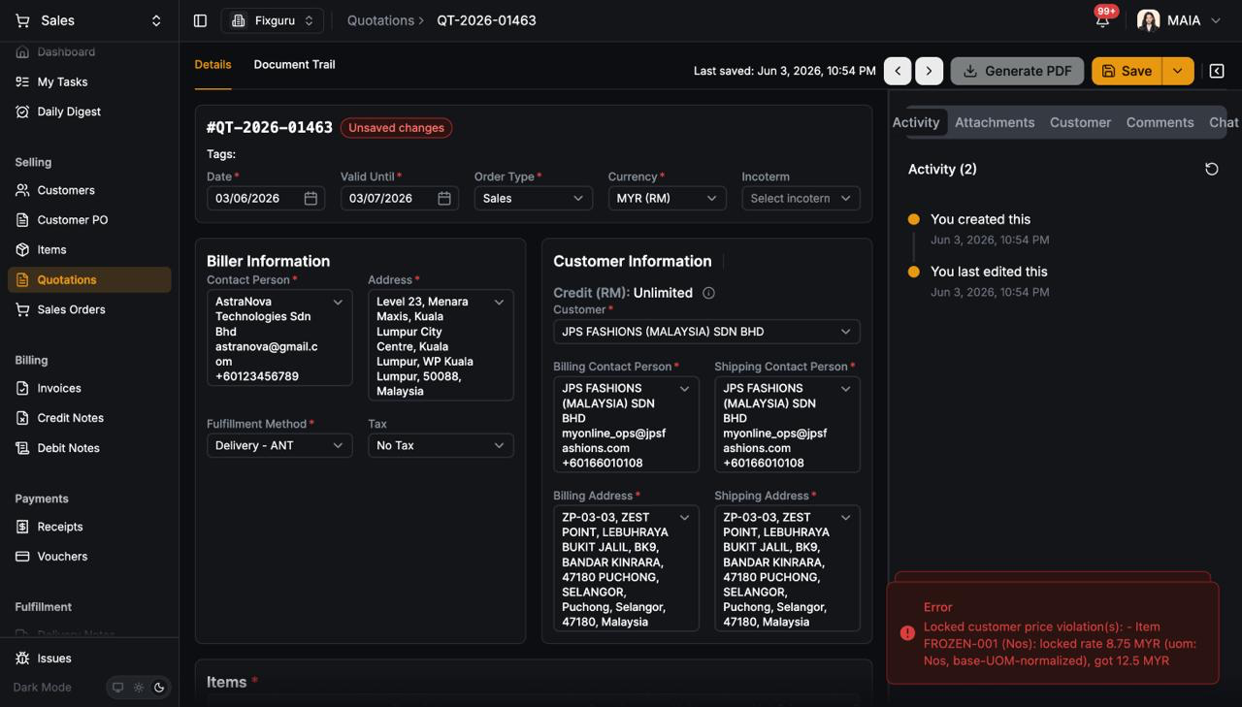
- Lock icon shown on unit price with tooltip "Unit price is locked", but field still editable
- Error only on submit: "Locked customer price violation(s): FROZEN-001 locked rate RM 8.75, got RM 12.50" (QT-2026-01463)
- Decision needed: Block at field (read-only when locked) vs block at submit (current)?
- Option A — block at field: cleaner, no ambiguity
- Option B — block at submit (current): user wastes time before hitting error
- Recommendation: Block at field — lock icon already signals intent
- Action: decide and implement consistently across QTN and SO

5. UOM Split — Chatbot vs FE Output Mismatch
Issue — Chatbot Response Does Not Match FE Actual Output
- Test: Asked chatbot to split A5 and A4 into different UOM lines (1×8PCS + 5×1PCS each)
- Chatbot said: Lines consolidated as 6×8PCS @ RM 1.81 and 6×8PCS @ RM 1.52 — claimed system consolidates units into stored UOM; added pick/pack remark as workaround
- FE actual (screenshot QT-2026-05448):
- A5 → 2 separate lines: 1 Pcs @ RM 1.81 + 5 Pcs @ RM 1.81
- A4 → split lines visible, UOM shown as Pcs not 8PCS
- Additional Notes on each line: SPLIT-8PCS - DO NOT CONSOLIDATE / SPLIT-1PCS - DO NOT CONSOLIDATE
- Discrepancy:
- Chatbot described output as consolidated 6×8PCS — FE shows split lines in Pcs
- Chatbot UOM label 8PCS does not match FE UOM Pcs
- Chatbot summary totals do not reflect the actual line structure on FE
- Severity: High — chatbot misrepresents what was actually saved; user cannot trust chatbot confirmation as source of truth
- Action: Fix chatbot response to accurately reflect the actual lines and UOM created in the system; chatbot output must match FE state

6. Shelf / Item Attributes (Chatbot)
Issue — Chatbot Cannot Retrieve Shelf from Item Attributes
- Test: Asked chatbot for shelf location of item H4 — "show where the shelf from", "h4 shelf", "search H4 item shelf", "search from its item attributes"
- Observed: Chatbot searched warehouses (bin/shelf locations) and returned no results. When prompted to check item attributes, returned item master fields (item group, UOM, price, qty) but reported "no shelf/bin field on its item record"
- Root Cause: Shelf is stored as an item attribute field, not as a warehouse bin/shelf location. Chatbot is querying the wrong data source (warehouse stock ledger) instead of item attributes
- Expected: Chatbot should surface the shelf value directly from item attributes when asked
- Severity: Medium — shelf lookup is a real sales/ops workflow; incorrect data source means it always returns nothing
- Action: Map chatbot shelf query to item attributes field, not warehouse bin/stock location

7. Chatbot shows correct total stock for items but per-warehouse breakdown returns "no per-warehouse stock record found" for all warehouses — including HQ which has confirmed stock in FE.
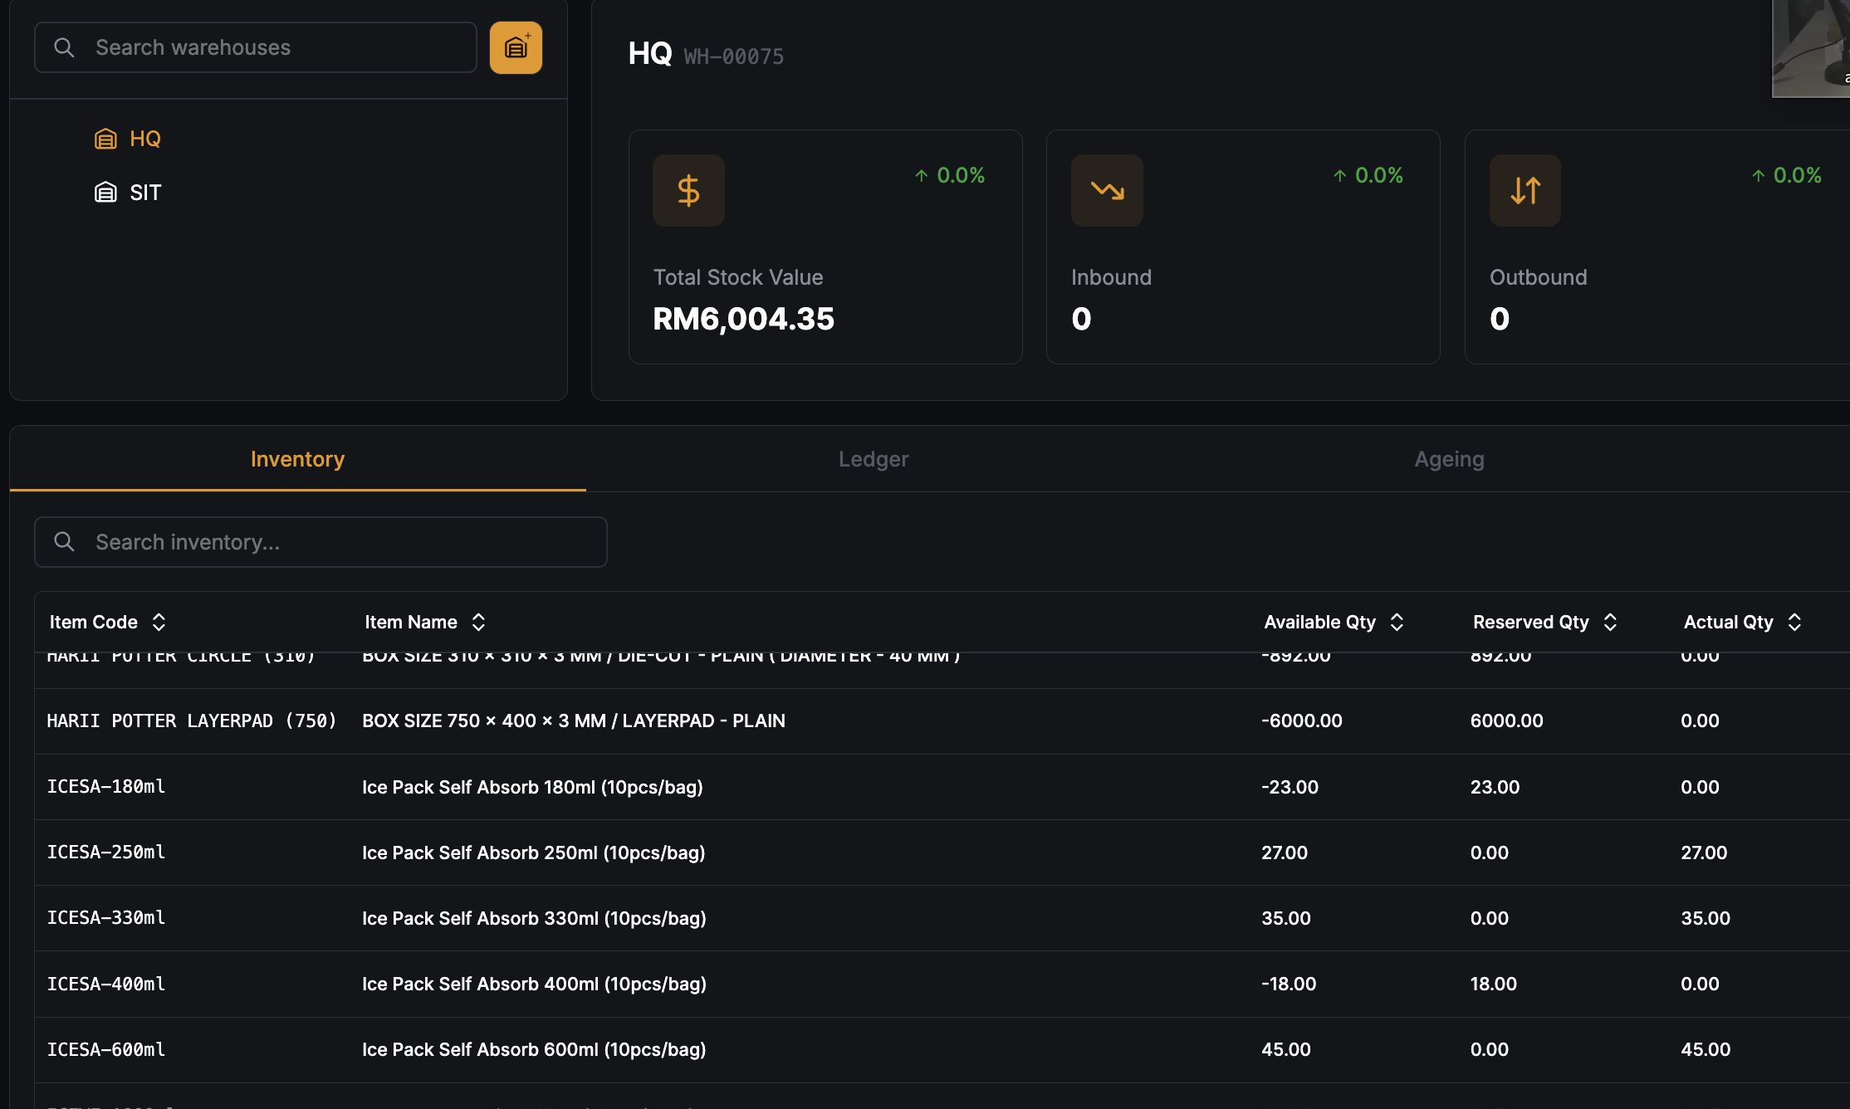
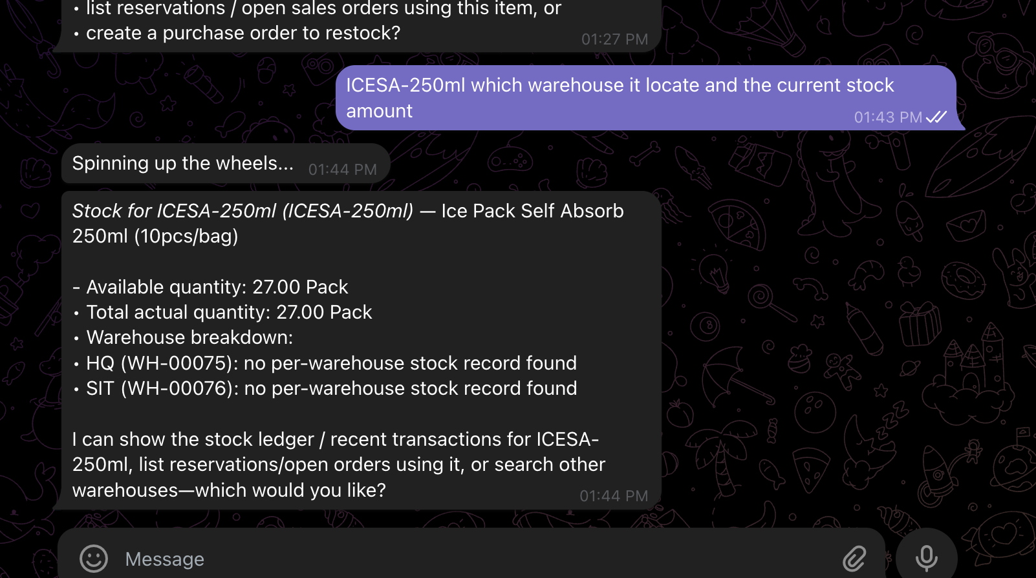

Evidence (ICESA-250ml):
- Chatbot total: 27.00 Pack ✓ (correct)
- FE HQ actual qty: 27.00 ✓ (confirmed)
- Chatbot HQ breakdown: no per-warehouse stock record found ✗
- Chatbot SIT breakdown: no per-warehouse stock record found ✗
- FE SIT: completely empty (RM0, 0 items) ✗

Root cause: Two separate queries in chatbot. Total stock query works. Per-warehouse
breakdown query broken — fails to return warehouse-level rows even when stock
exists. Likely wrong or missing join on warehouse_id in breakdown sub-query.

Scope: Both warehouses affected. SIT empty may be separate data issue (no stock ever
moved there) or same broken query masking real data.

Dev action: Fix per-warehouse breakdown query — confirm join to warehouse stock
table uses correct warehouse_id filter and returns rows per warehouse, not just
aggregate total.

8. When calculating DW in the custom cal, recommend selling price is not generated
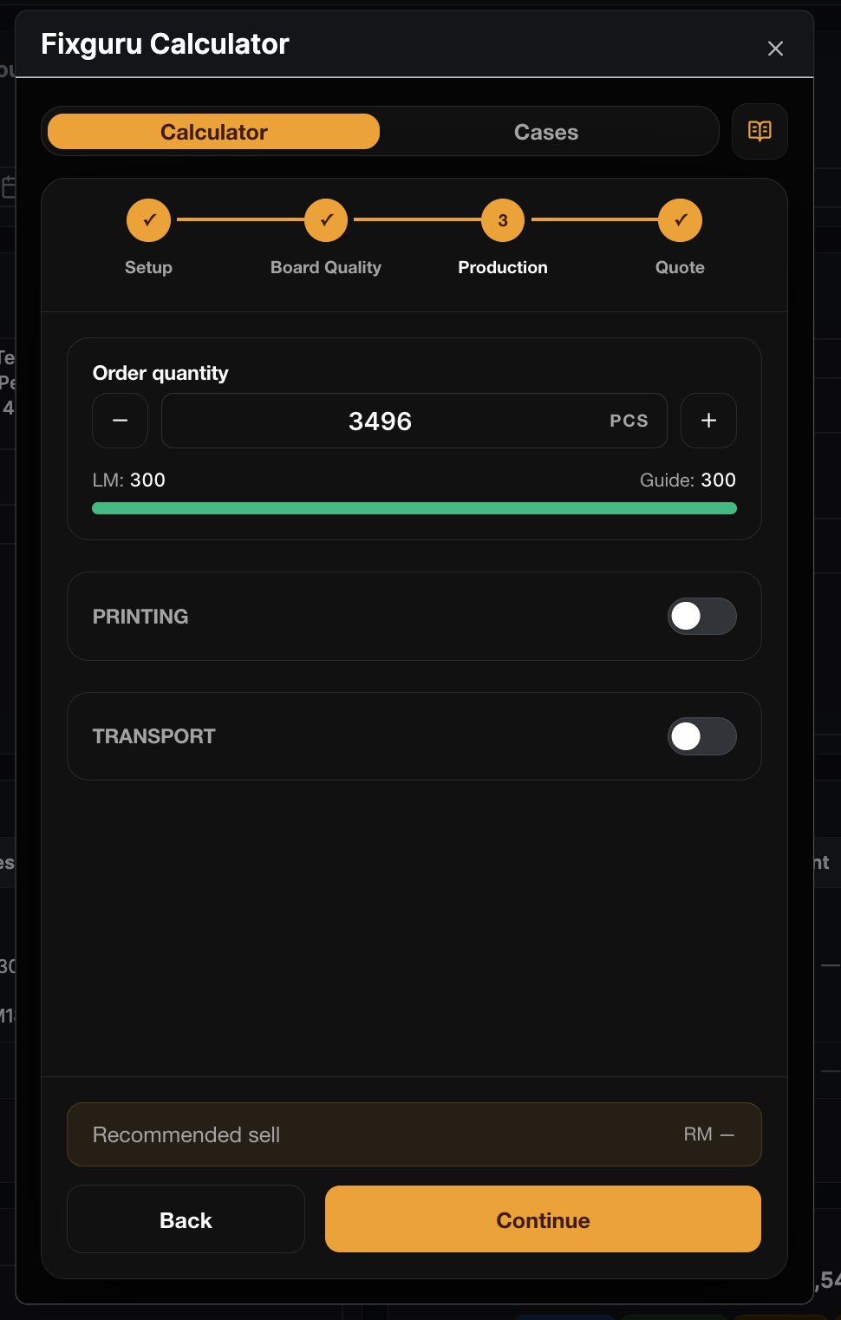 | 